ICE SCRUBBER CRATING INSTRUCTIONS

Uncrating

Tools required:
Screw drill with #2 Phillips bit
2 fully charged batteries and a charger! ( cannot pack batteries in to checked luggage, must place them in carry-on)
Bag for all of the screws/bolts, etc.
#2 Phillips screwdriver
tape

Note: Save all parts / fasteners for reassembly.

- Remove Crate Top / Ramp by removing 6x Fasteners securing. Fastener location identified by orange paint. Set aside to be used as ramp to remove scrubber from pallet. Save all fasteners.
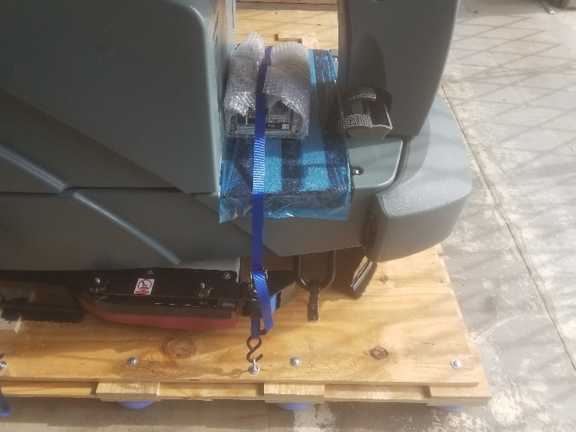
- Disassemble and remove 4 crate walls by removing all Fasteners. Set aside for reassembly. Note the numbers on the walls and the floor of the crate line up (3’s all line up, 4’s all line up, etc).
- Remove charger (Gen 1), literature pack, and any other accessories that may be included with scrubber and set aside.
- If disassembled, install Beacon Light onto scrubber by connecting electrical connector and securing with 3 fasteners. Note: Clock beacon so that fasteners on base align with relief holes.
- Using screw drill, remove 2x brackets securing skid bars to floor of pallet.
- Tape the screws to the skid bars so you don’t lose them. This will help when you re-crate
- Loosen and remove strap securing rear of scrubber to pallet.
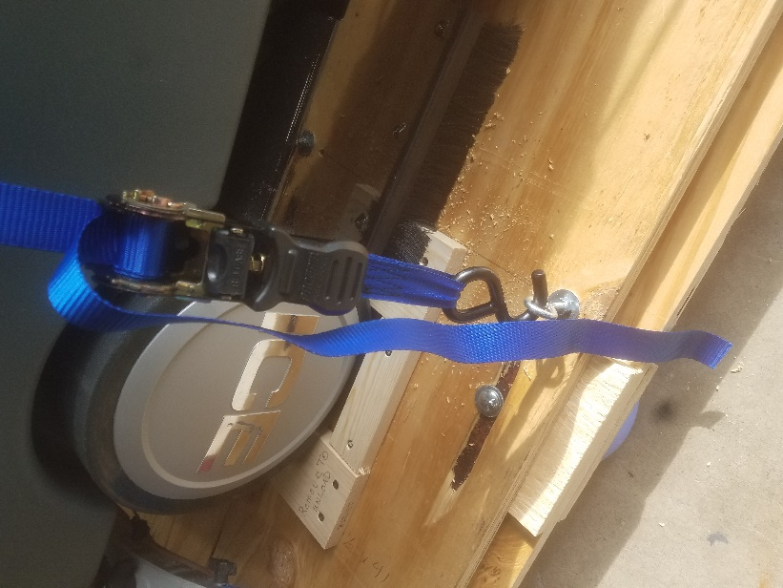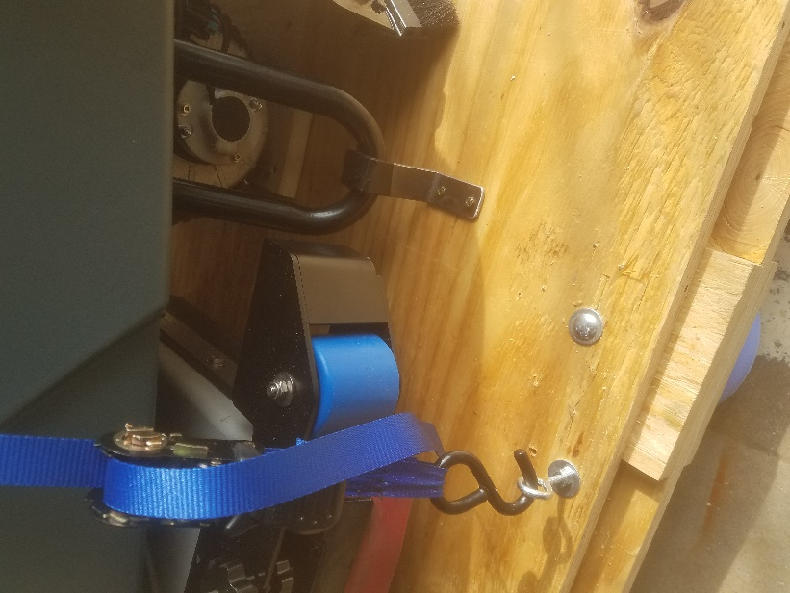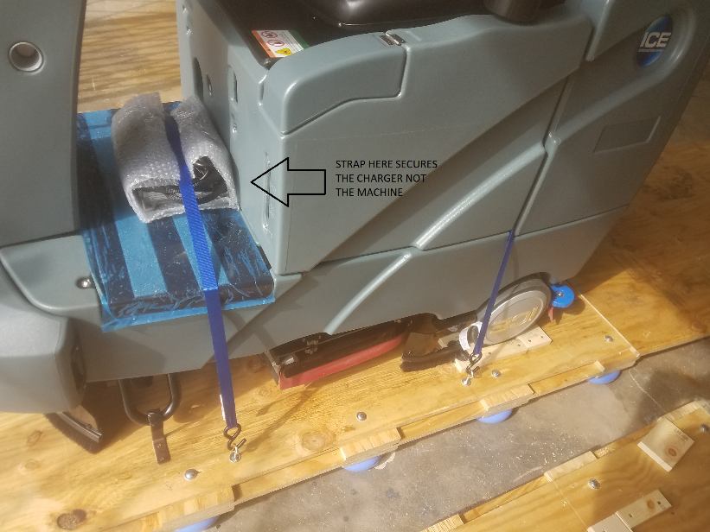
- Using screw drill, remove 2x wheel chocks located behind the rear wheels. (Not necessary to remove any other wheel chocks).
- Screw the fasteners back into the blocks so you don’t lose them. When you recrate, you have the right pieces together.
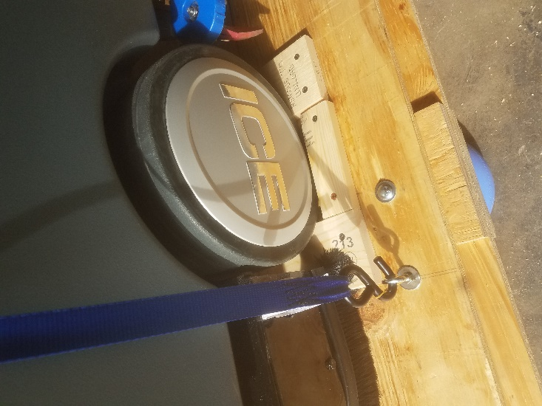
- Align ramp with pallet to the rear of the Scrubber. Edge of ramp should overlap and be supported by blocks at end of pallet.
- Check the scrub deck and make sure pads/pad drivers are removed.
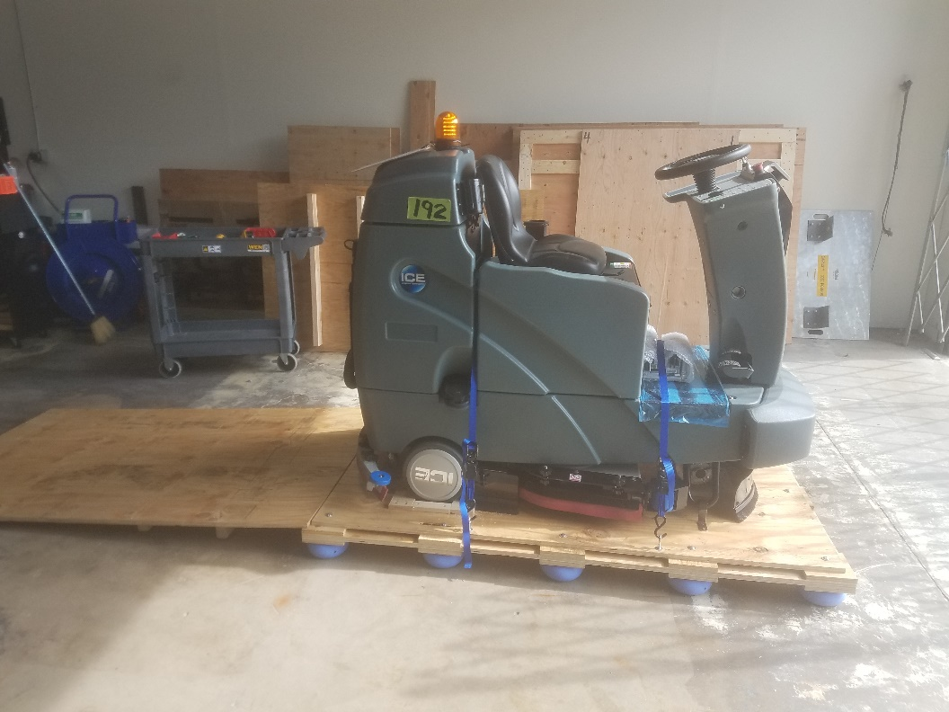
- Sit on scrubber. Power on scrubber with Key, and allow to boot (wait for UI screen to appear). Select reverse using rocker switch.
- Slowly back scrubber off pallet using ramp. Always drive in reverse off of the ramp.
- When reassembling, note the numbers on the pieces and line them up. Last piece is the ramp/top.
- Ensure wheels are aligned within the blocks.

