Machines
Machine | Various TASKI swingo
Subassembly | Magnetic valve

New magnetic valve for TASKI swingo machines
For a long period of time we have noticed a large failure rate on the 24V magnetic valves. In summer 2016 we decided to stop modifications on the existing valve. A new development with a well-known manufacturer of magnetic valves has started at that point of time.
The result of this close collaboration is a brand new 24V magnetic valve for our medium sized scrubber drier machines.
Almost all parts of this valve are customized to our requirements. Only the filter and the angle nipple were taken over from the old design. For prevention from jamming caused by calcification, a teflonized valve core has been built in. The water flow in the valve is better than ever and the opening of the valve up to three times larger, in order to avoid any clogging.

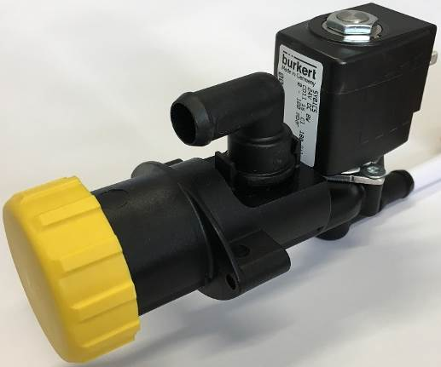 | 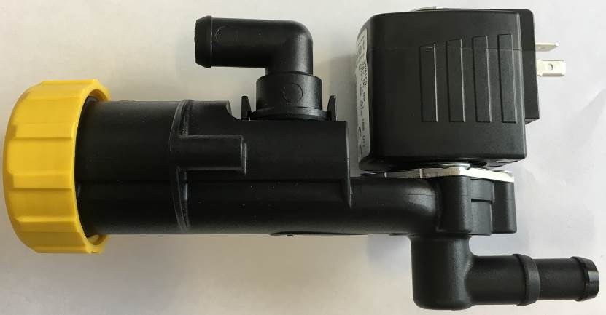
View of the new magnetic valve type.

Description | Material number | Remarks
Magnetic valve 24V | 4126924 (17700-07) | Existing spare part number

Service Information

Production
TASKI swingo 455B as of machine number 27206
TASKI swingo 755B/855B/955B/1255B as of machine number 59462
TASKI swingo 760B/1260B at release of this newsletter not yet known

