M12 and 38999 Connector, Wiring, and Signal Guide

Contents
1. M12 Connector Types and Pinouts 2
2. MIL-C-38999 BCM side connector pinouts 3
3. Up-trunk M12 connector signals: 5
4. Down-Trunk M12 Connector Signals: 6
5. Power-Trunk M12 Connector Signals: 6
6. UI Touchscreen Display 7
7. Probing adapters 8

- M12 Connector Types and Pinouts

We use the following types of M12 connectors

M12, 4 pin, type A (Male and Female)
M12, 4 pin, type D (Male and Female)

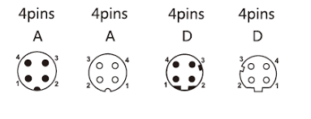

M12, 5 pin, type A (Male and Female)

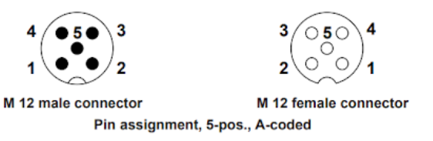

M12, 8 pin, type A (Male and Female)

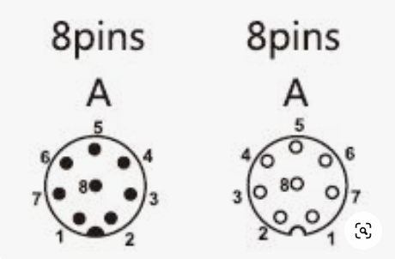

- MIL-C-38999 BCM side connector pinouts

D38999 Harness | Upper Trunk | Down Trunk
Brain Part Number | 215-00139-01 | 215-00169-01
Brain Part Name | 38999, 66-Pin, N, M, D38999/26FF35PN | 38999, 66-Pin, A, M, D38999/26FF35PA
Manufacturer | Souriau | Souriau
Manufacturer PN | D38999/26FF35PN | D38999/26FF35PA
Shell Size | F | F
Contact Layout | 35 | 35
Number of Contacts | 66 | 66
Where-used Assy | 810-00200-XX  810-00212-01  810-00219-01 | 810-00129-XX  810-00209-01  810-00221-01
Figure No. | 1 | 1

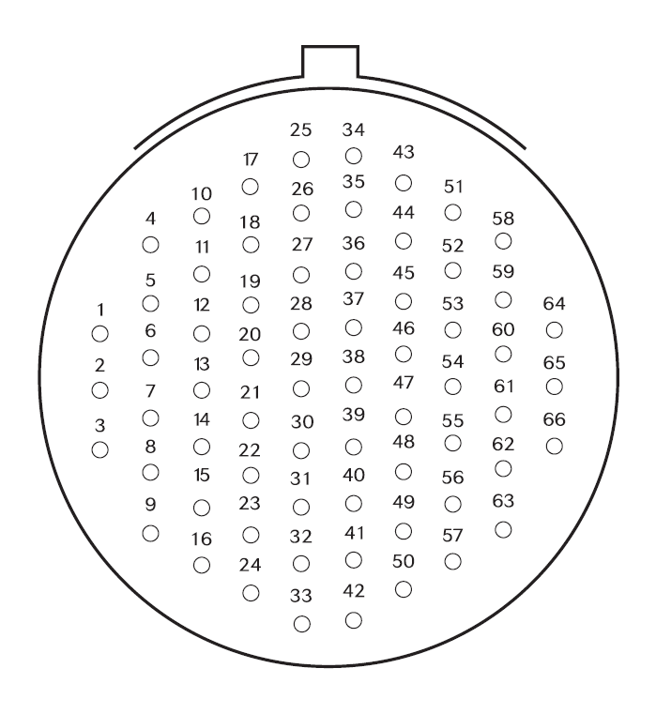
Figure No. 1: Front Face of pin insert

D38999 Harness | Power Trunk
Brain Part Number | 215-00170-01
Brain Part Name | 38999, 8-Pin, N, F, 8D5-13F26SN
Manufacturer | Souriau
Manufacturer PN | 8D5-13F26SN
Shell Size | 13
Contact Layout | 26
Number of Contacts | 8
Where-used Assy | 810-00132-XX  810-00213-01
Figure No. | 2
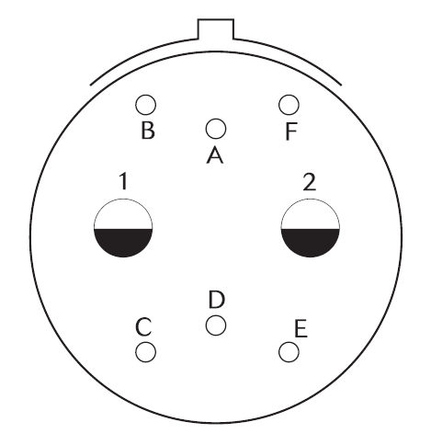
Figure No. 2: Front face of pin insert

D38999 Harness | Display
Brain Part Number | 215-00171-01
Brain Part Name | Housing, D38999, 22-Pin, N, M, D38999/26FC35PN
Manufacturer | Souriau
Manufacturer PN | D38999/26FC35PN
Shell Size | C
Contact Layout | 35
Number of Contacts | 22
Where-used Assy | 810-00130-XX  810-00223-XX
Figure No. | 3
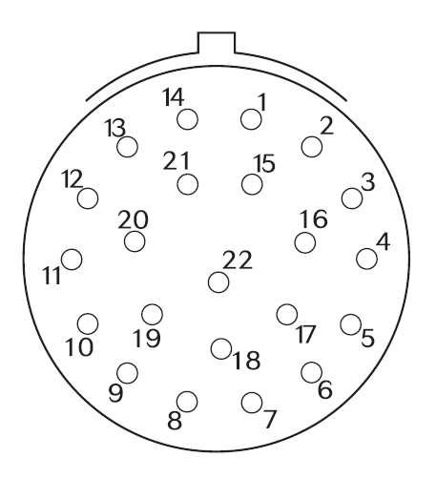
Figure No. 3: Front face of pin insert

The following signals are carried on M12 connectors. See the specific Up trunk 810-00173-01, down trunk 810-00129-01, and power trunk 810-00132-01 drawings for more details
- Up-trunk M12 connector signals:

Up-trunk Drawing P/N 810-00173-01
“CAM” are the RGB cameras (USB)
This end column shows the M12 connector type A or D , number of pins, and male or female

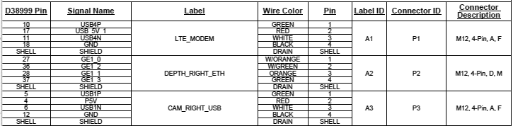

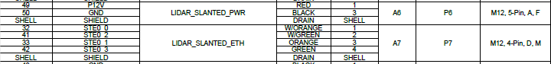

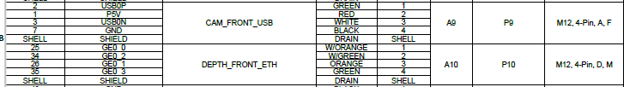

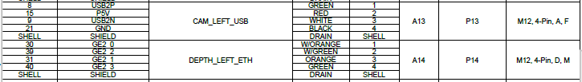

- Down-Trunk M12 Connector Signals:

Down-trunk drawing P/N 810-00129-01
ENC_ABS is the steering encoder AKA absolute encoder

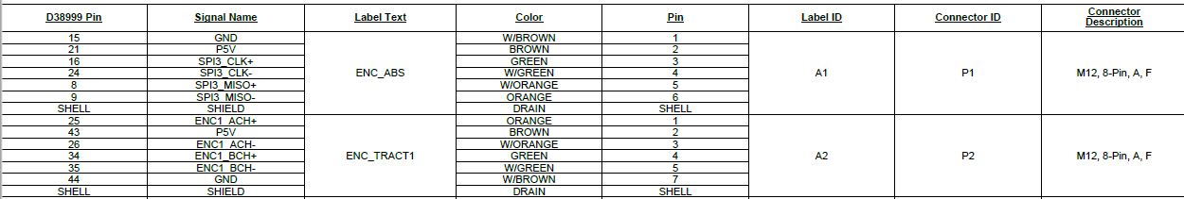

- Power-Trunk M12 Connector Signals:

Power-Trunk Drawing P/N 810-00132-01

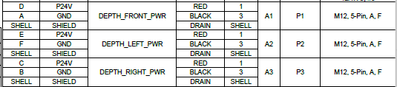

- UI Touchscreen Display
UI Touchscreen Display Cable P/N 810-00130-01

Video Display (LVDS)

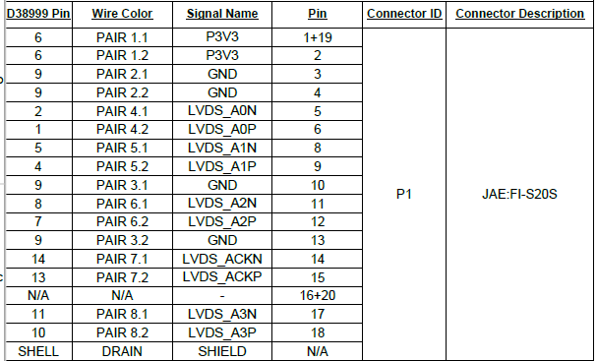

Backlight
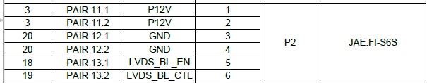

Touch Detect (USB)

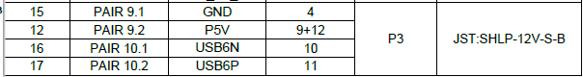

- Probing adapters

These adapters are useful to help probe the connectors. They are available on amazon at

https://www.amazon.com/EDGELEC-Breadboard-Optional-Assorted-Multicolored/dp/B07GD2BWPY



